User Registration Page and Database Connection

Click on Users.

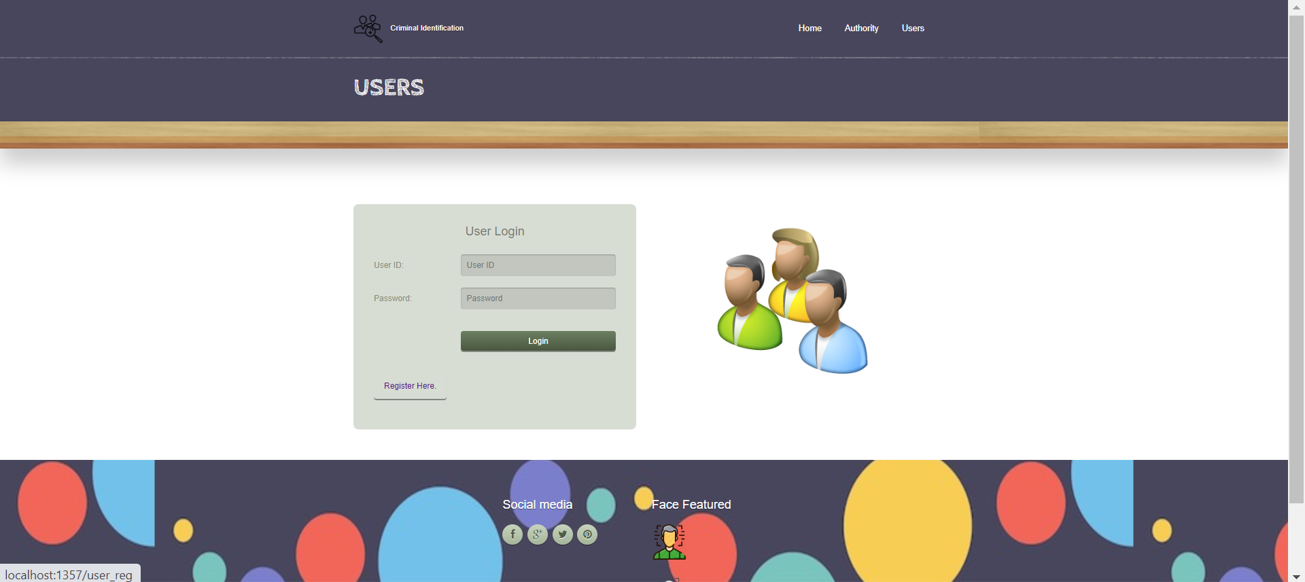
Click on REGISTER HERE to register as a user.

It is also same as authority, first we will go to login page if already registered we can give login details if not registered we can click register.
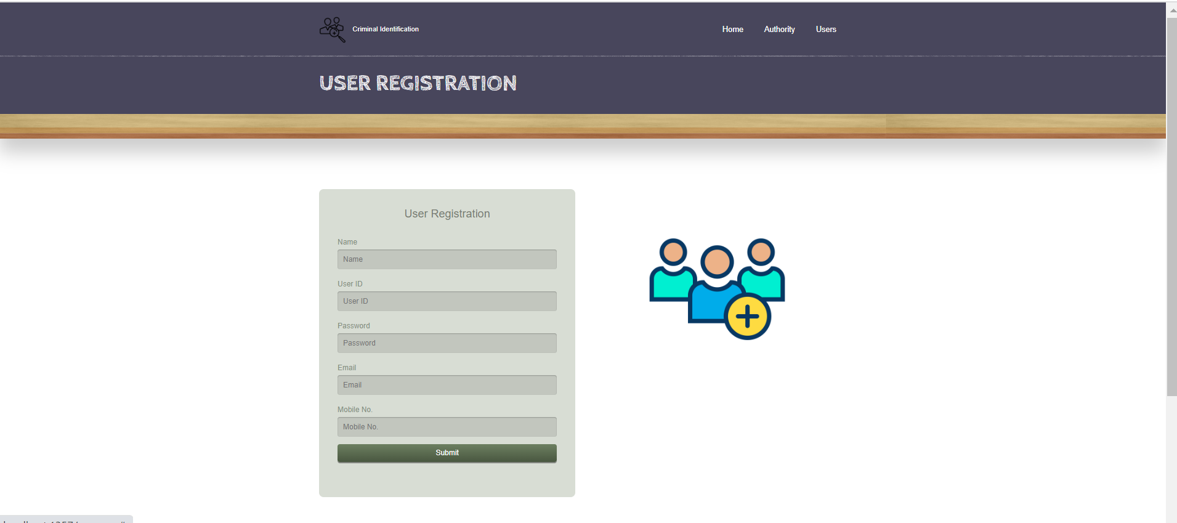

Fill the required details and click submit.
Code: to register – user_reg.html
To login – user.html
When registration is successful, check in users table in database whether details are filled.
